**Selected - 1**



**Number Team : 5**

Prepared by:

1. 202000076 احمد محمد محمد امام عبدالفتاح
2. 202000899 مصطفى حماده جمال محمد
3. 202000081 احمد محمود حمادة محمود
4. 202000812 محمد كمال عبدالحفيظ محمد
5. 202000051 احمد عصام عبدالفتاح العدل
6. 202000022 احمد جمال حسيني علي
7. 202000544 عبدالله أشرف السيد احمد

**Faculty Name : Computers and artificial intelligence Helwan**

**Image Dataset**

**\*\*General Information :**

## 1. The Name Dataset : Columbia Object Image Library (COIL-100) Dataset

**2. Number of** **Classes : 100**

**Their Labels: 20**

**3.Total Number of** **Samples : 7200 image**

**The Image** **Size : 128*128*3**

**4.** 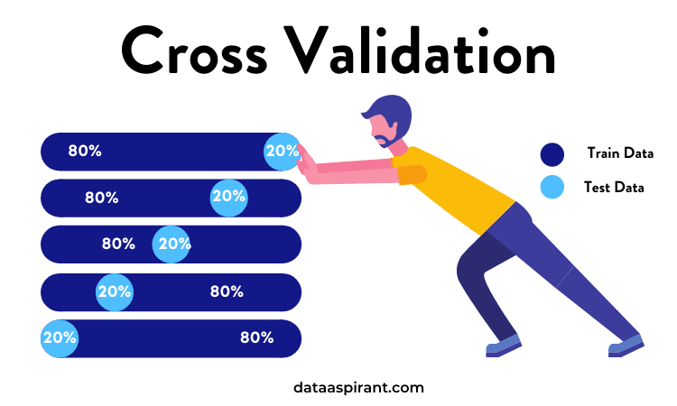

**Number of Training : 5040**

**Number of Testing : 2160**

**Implementation Details:

**1. At feature extraction phase : There is no in the model**

**2. Is cross-validation used? Yes**

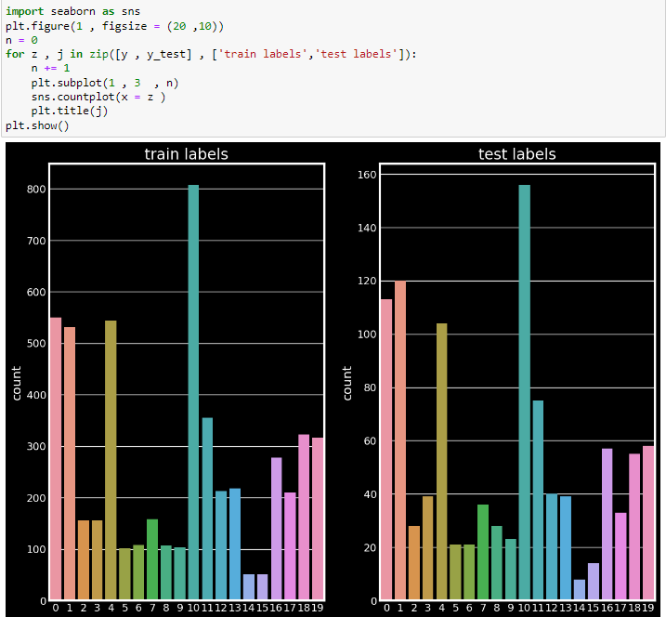

**Number of Training : 5040 = 70%**

**Number of Testing : 2160 = 30%**

**3.Hyperparameters used:**

**1. Learning Rate = 0.1**

**2. Optimizer : Adam "tensorflow"**

**3. Regularization : Overfit the Dataset :**

**4. Batch Size = 128**

**5. Number of epochs = 10**



**" We use 10 epochs, stopped in 4 epochs with accuracy = 99.16% Then we increase epochs to 10 epochs with accuracy = 99.25%"**

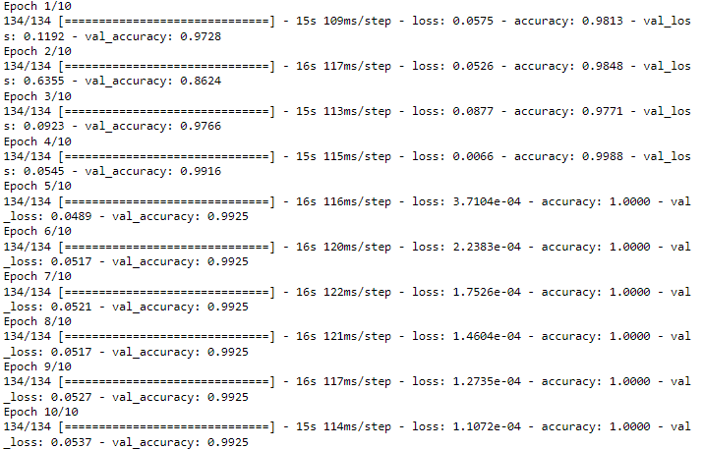

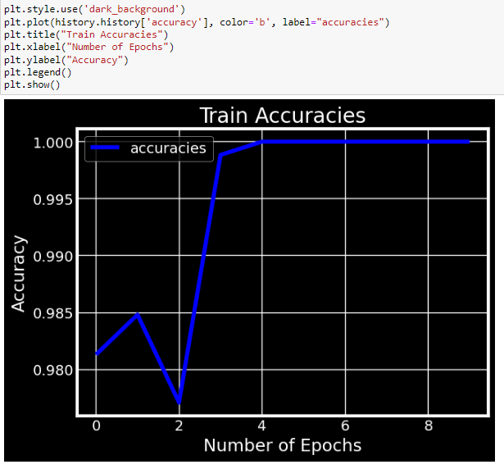

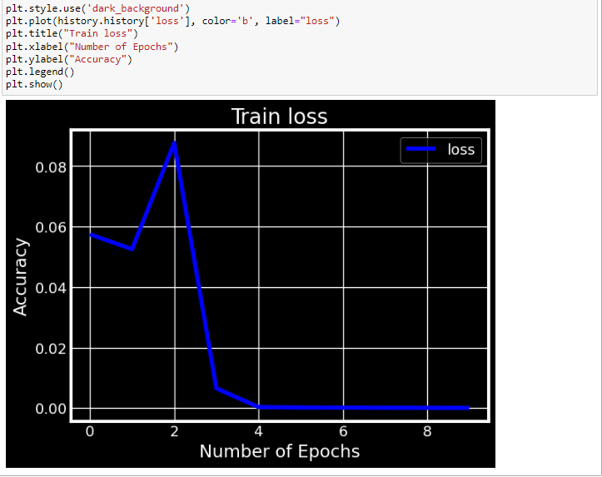

**\*\*Results Details:**

**1. Loss curve :**

**a. Train loss & Accuracy:**

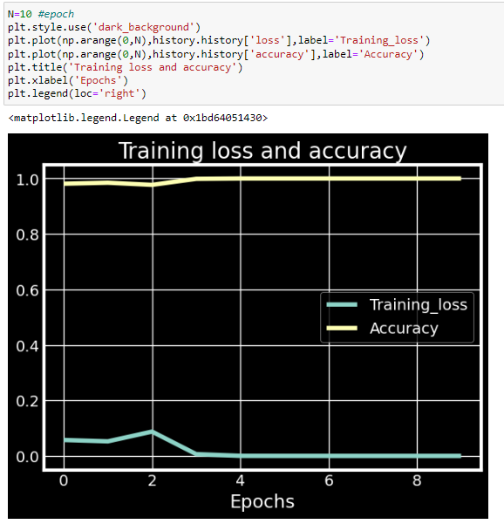

**b. Training & Validation loss:**

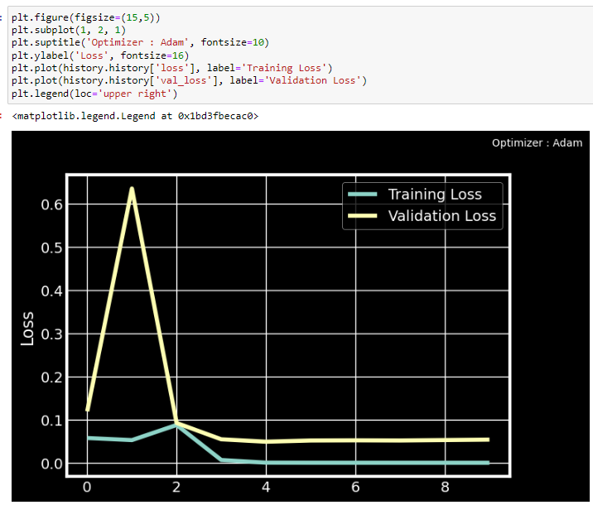

**2.** **Accuracy :**

**\* Training & Validation Accuracy:**

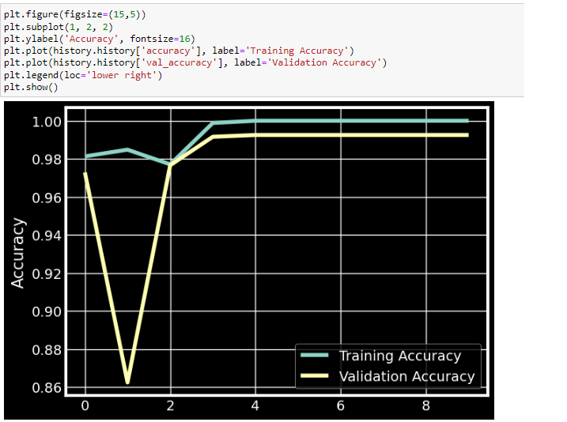

**3. Confusion Matrix:**

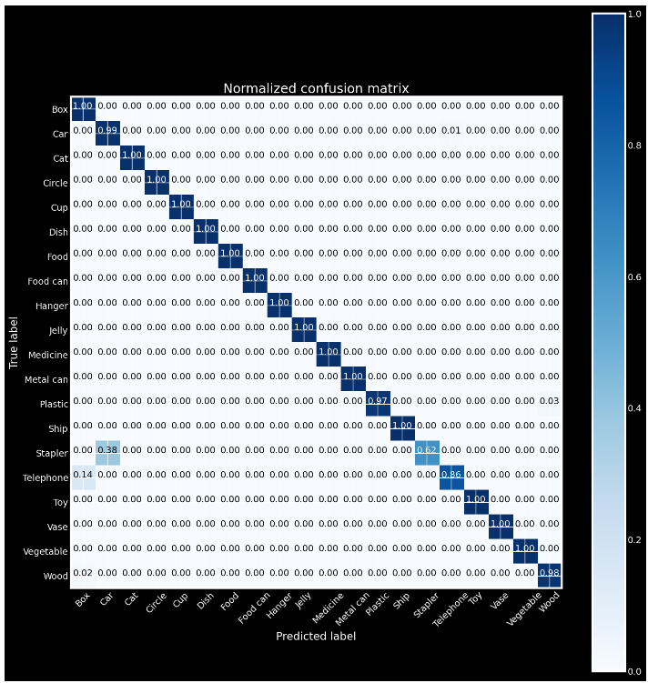

**4. ROC Curve:**

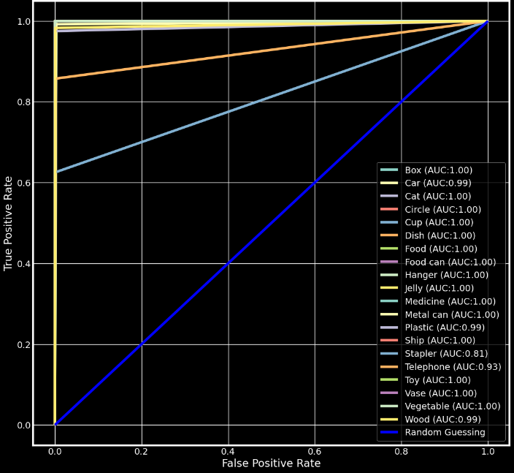

** Classification Report :

